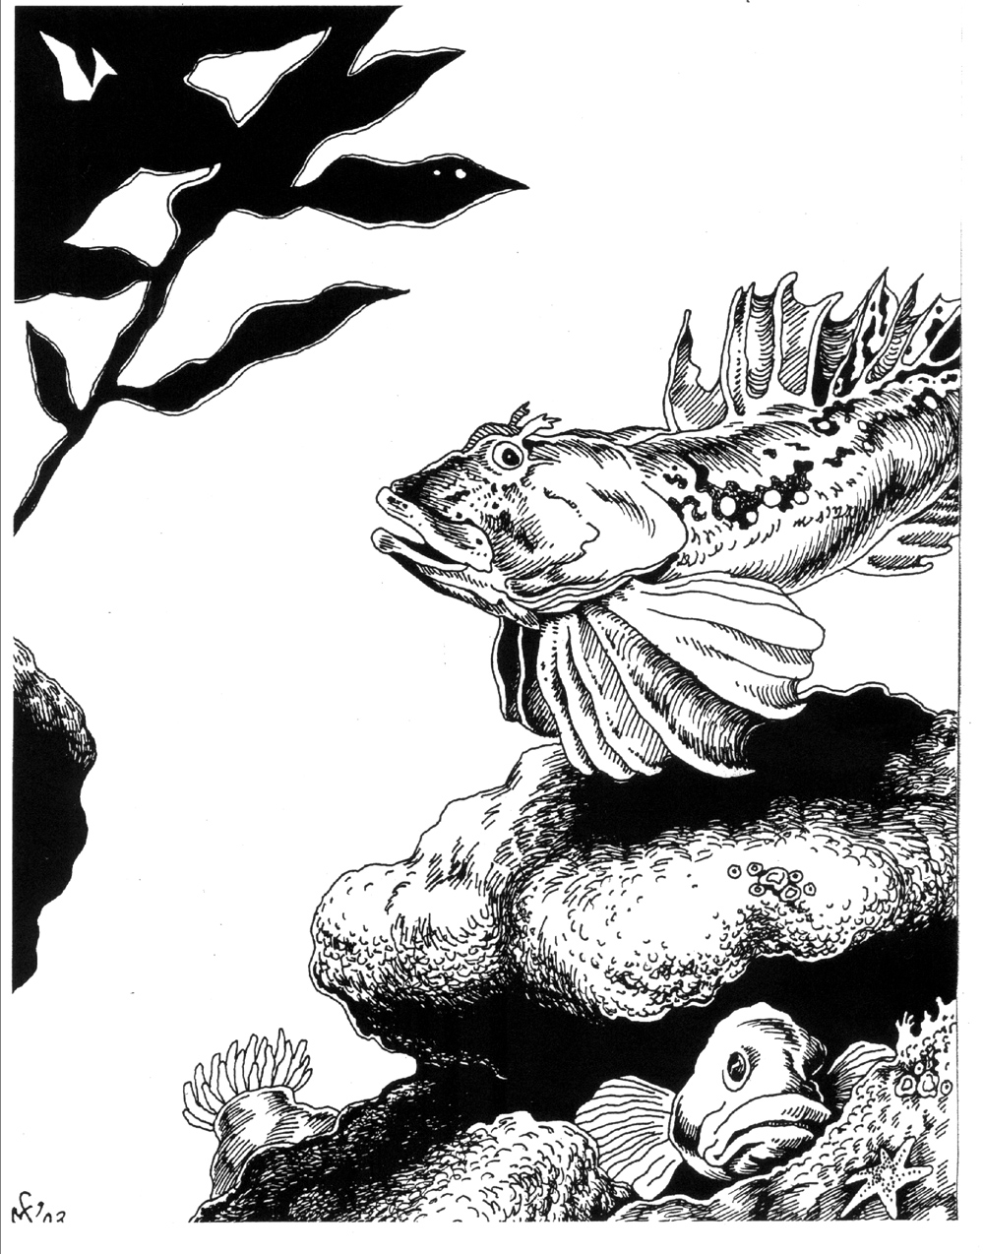
Hey everyone, it’s the…
MONKEY FACE NEWS
A Biannual Compendium of
Meaningless Fishtales, Scurrilous Half-Truths
and
Out and Out Lies

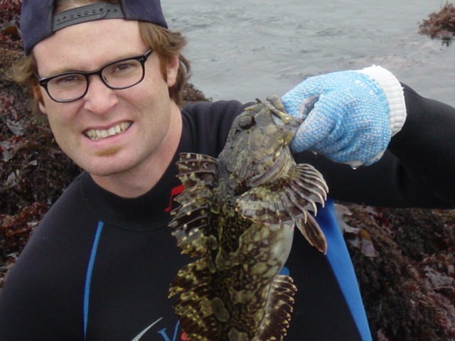

The author, here pictured with a reasonable cabezone.

-Volume 3-
Confessions of a Squackman
Lombard Of the Intertidal—Nearly
Swept Out To Sea While Poke Poling

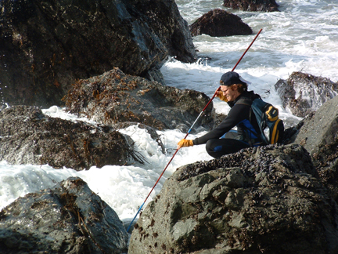
1. A Promising Nibble.

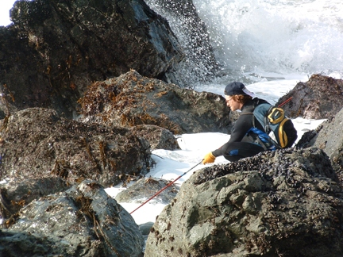
3. Disaster Looms.

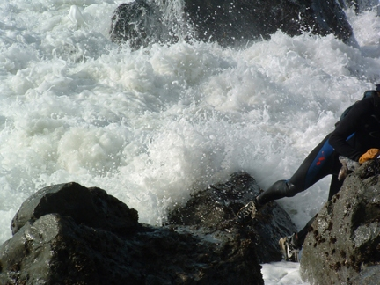
5. A Mad Dash.

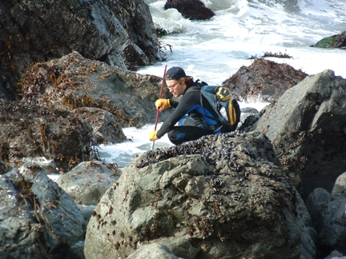
2. Momentarily Preoccupied.

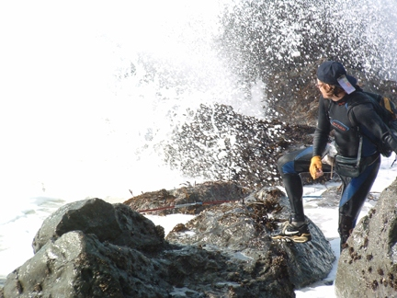
4. Look Out!

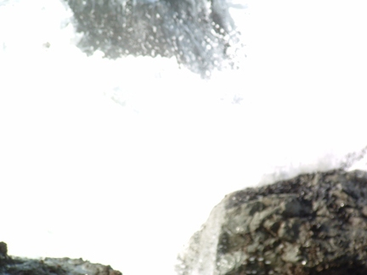
6. Wrath of the Sea.

Photographs by Michael Larry Henderson

Part 1
Hibben’s Eel

In his classic (though admittedly outdated) treatise on the peoples and cultures of the inner Trobriands, The Tubular World Of Anana: Eels And Identity Among The Primitive Tribes Of Middle Caledonia, C.F. Hibben describes, in several heavily annotated volumes, the importance of the lesser Pacific pricklebacks to the ritual complex of various Micronesian tribes. In retrospect it can only be imagined what pearls of ethnographic insight Hibben might have penned had he not been devoured by his gigantic manwife, Gollkwaa-k!-hibben-dawana, (or, prophetically, “she who will one day devour Hibben”), the summer before his residency on the Isle of Bwana was to be terminated (by certain jealous parties at the highly esteemed ivy league university for which he so diligently labored in the final 18 years of his turbulent and unhappy life).

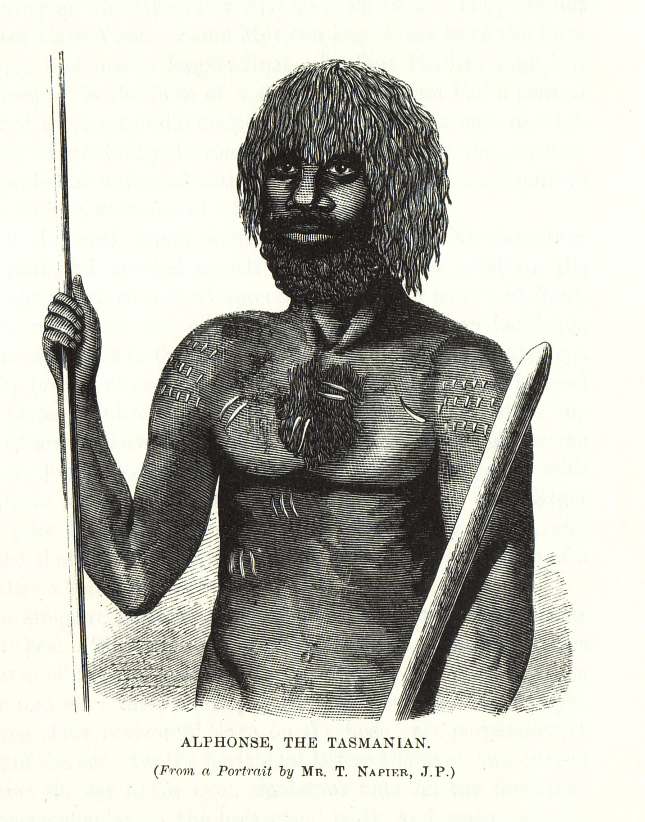

Certainly, Hibben’s work on the sexual implications of the inner Trobriandian penis thong/dug-out canoe totemic structures indicates the penchant for complicated abstraction and insightful (if at times perplexing) wordplay so important to the postulates, axioms and semi truths of most great anthropological theorists.
According to Hibben, (Vol. 2, Ch. 78, pg. 1,104) all inner Trobriand islanders view the cosmos as a “series of interconnected bladders, filled with air, floating on the surface of a gigantic celestial vagina, perpetually besieged by the sperm-like advances of a vast phalanx of thickly muscled and heavily toothed, monkey-faced eels.” A quick perusal of Hibben’s 8,011 page opus: Letters To Myself, written over the course of the 27 years preceding his first inner Trobriand foray, will show, to even the most casual of readers, that Hibben himself had achieved a chillingly similar cosmic viewpoint to that of his later subjects, long before the infamous “bladder—eel synchronization of 1921,” (as he so inexactly puts it,) when, upon relocating to the inner Trobriands, he discovered, much to his satisfaction, that he shared with the naked root-eating inhabitants of the region, a strikingly similar floating-bladder-while-besieged-by-eels weltanschauung—a uniquely inner Trobriandian weltanschauung of which Hibben, evidently, had no a-priori knowledge.

2. This Book Will Ruin You
Unless you are one of the three qualified people for whom Hibben (happily, on page 2 of his 285 page introduction to volume one) tells us he has specifically written this series of books, do not bother with it; taken singly or as a whole the work far exceeds your capacity as a reader and will inevitably ruin you. Instead, find yourself a copy of one of his more comprehensible pieces, like for instance, the almost embarrassingly personal: I Am My Wife, or the terse, rugged: Hunting The American Lion: Two Years On The Trail Of The Catamount In Northern Wyoming.
It is hot as a bastard in this windowless room right now. The fan does nothing but blow warm, dust-filled wind against my sticky nape and shoulders.

3. Hibben Was A Big Man
Unfortunately, most of the biographical work concerning the savant pertains To his gargantuan appetites and skill in pie eating contests. This is a perplexing displacement of historic emphasis, which, given the obvious significance of Letters to Myself, the present author is at a loss to explain.
However incidental they may appear to the core theses of the completed Hibbenaiea, the prodigious acts of gluttony described by virtually all of Hibben’s commentators, from Roithammer (Hibben’s Maw, pp. 37-51) to Hatchjaw (DeSelby’s Life and Times p.132) are not to be completely ignored. It has been written by many scholars—whose powers of erudition are far superior to mine—that Hibben was capable of consuming “not just those foods placed within the span of his unyielding, outstretched and trunk-like arms, but all things within earshot of his Ruthian face and forehead—all things within the scope of his tiny, deep-set eyes,” (Hatchjaw, DLT p. 509)
In short, Hibben, despite his bleak end, was a man of tremendous girth (appetite potential) and linguistic capacity. Both his understanding of the eel/thong totemic structures of the inner Trobriands and his terrible hunger for all things underscore a deeper sensitivity and a tragic potentil for brilliant and flowery (if at times vague and aimless) extrapolation the likes of which you and I can never (even on our knees, in the dark, palms pressed flat together), hope to comprehend.

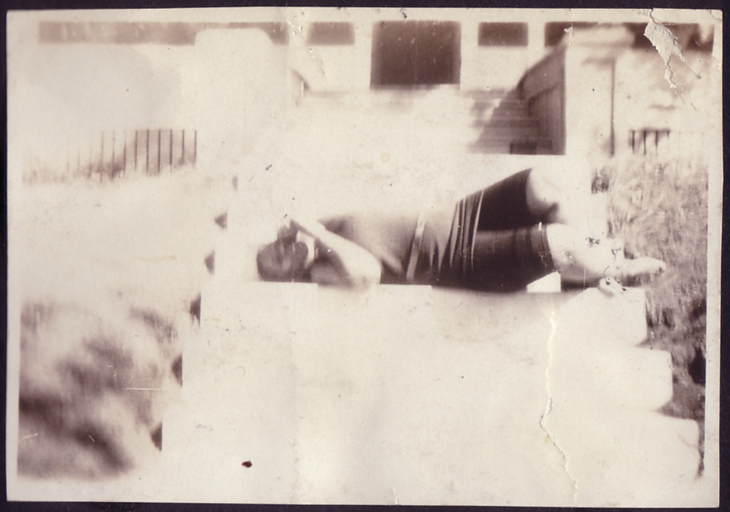
A rare moment of total repose

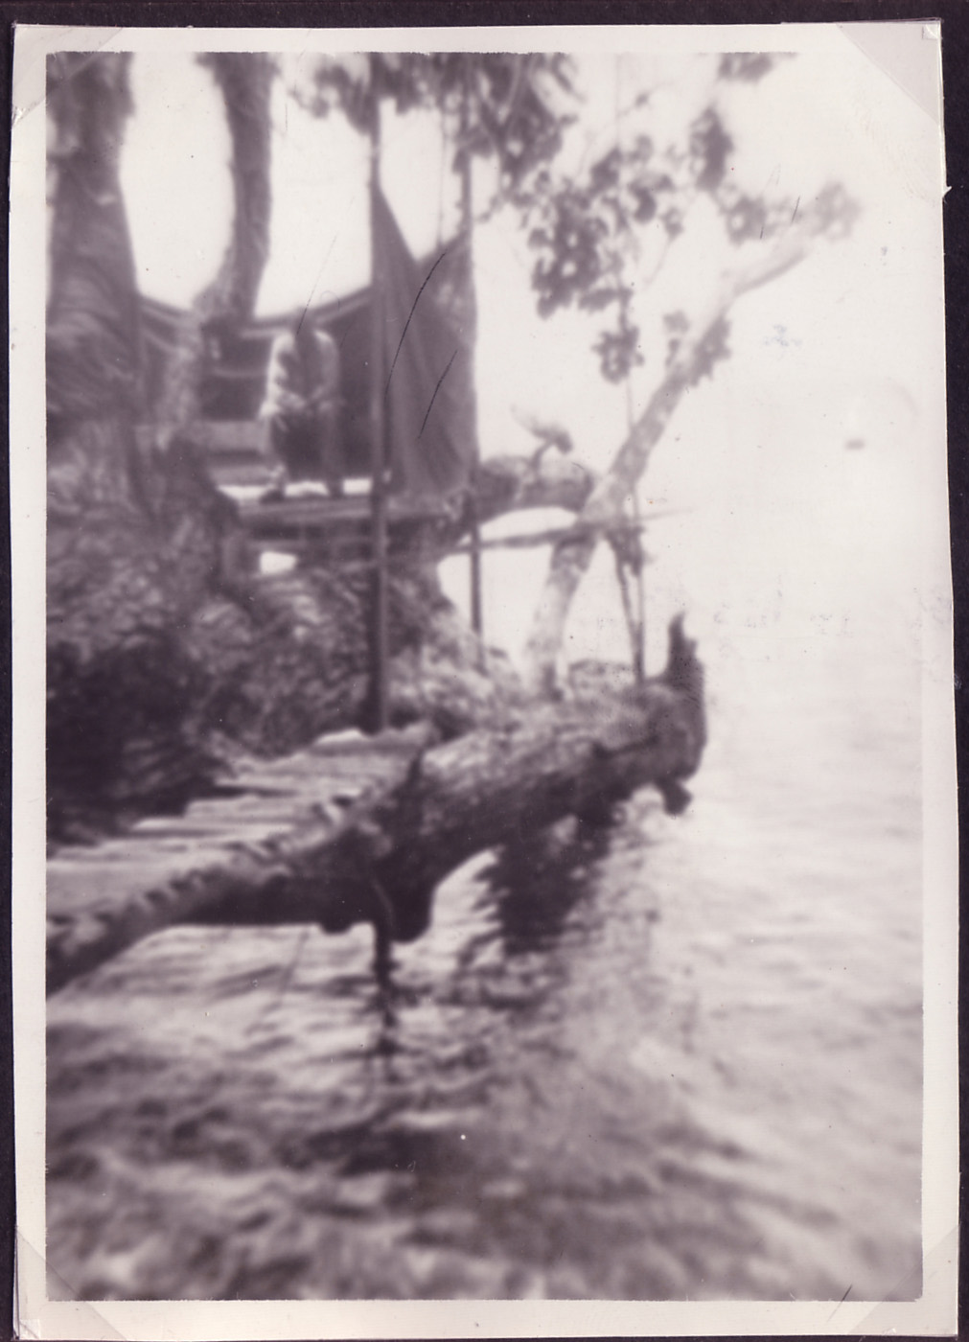
“Salvation Camp,” Inner Trobriands, 1922
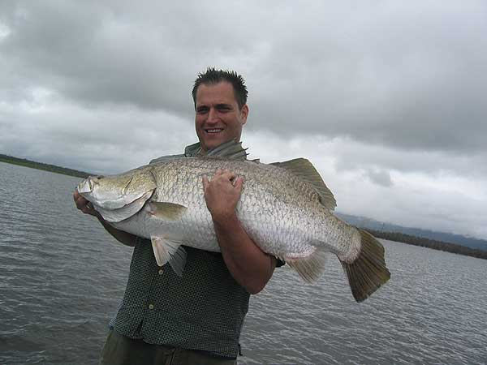Monkey Face News Resident Lexicographer John Paczkowski and his 40lb. 3 oz. (contested) Barramundi
1. squack (skwk) v. :
- To fish unsuccessfully.
- To engage in any process whereby the effort outweighs the gain.
2. squack (skwk) n. :
A ritualized humiliation ritual specific to the Red Faced Northern California Lombard. Typically involves immersion in fetid water while clothed in a senseless array of ponchos, waders, and wetsuits, all of which leak. Squack is most often witnessed in the tidal areas of Pescadero, where the naturalist, if he be stealthy and has masked his scent with a paste of piss clams and old squid, can sneak within a few yards of the Lombard and watch as it troubles tide pools in the hopes of capturing and dining upon one of their bowel shaped residents—the monkey faced eel. The first squack was documented by Paczkowski in '95 when he, a practiced fisherman, stumbled across a Lombard mucking about the Tracy sluice for piss clams and cunnyfish. At the time, the astonished Paczkowski had no idea what he was witnessing. Years later while recounting the experience, Paczkowski said he'd only approached the poor creature because it appeared to be in distress.

“At first I was planning to call Fish and Game, because it looked like it had injured itself
and needed to be put down,” Paczkowski explained. "But then I got a closer look and
decided it was best left to its own devices."

Part II
The Pelican Brief

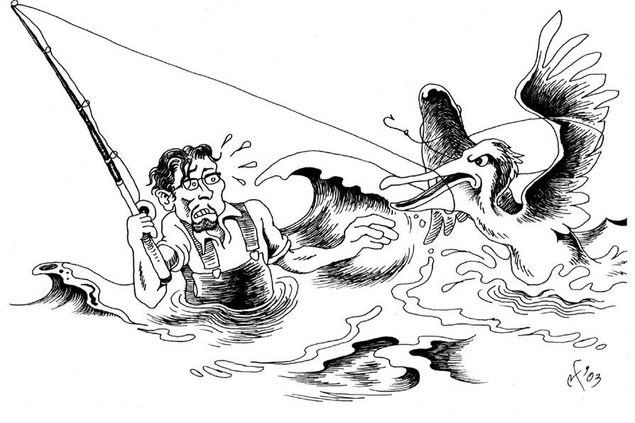

“A great, white, winged alligator.”

1. Yesterday While a’ Fishin’

Yesterday while a’ fishin’ I bore witness to the gut wrenching spectacle of a pelican, ensnared in monofilament line, desperately attempting to flap, paddle, and otherwise haul itself out of a tumultuous sea.
That this line was mine, and that I had recently cast it from shore, taking into account the problems of trajectory, the risks involved, and the likelihood of snagging the giant bird, only served to underscore my guilt and reinforce, (in the fecund wonderland of my eel-obsessed brain), that the blame for the inevitable tragedy would be mine and mine alone to bear.

2. At Length Did Cross An Albatross

Yes, as I zipped past Pescadero in Camilladilla’s recently lubed, scrubbed and dingle-balled Probe, I beheld a sight that would have driven any self respecting baitman to the brink of total orgasm: a teeming school of anchovies, had been corralled by pelicans (and who knows what sub-aqueous behemoths) to the edge of a narrow sandbar, no more than 60 feet from shore!
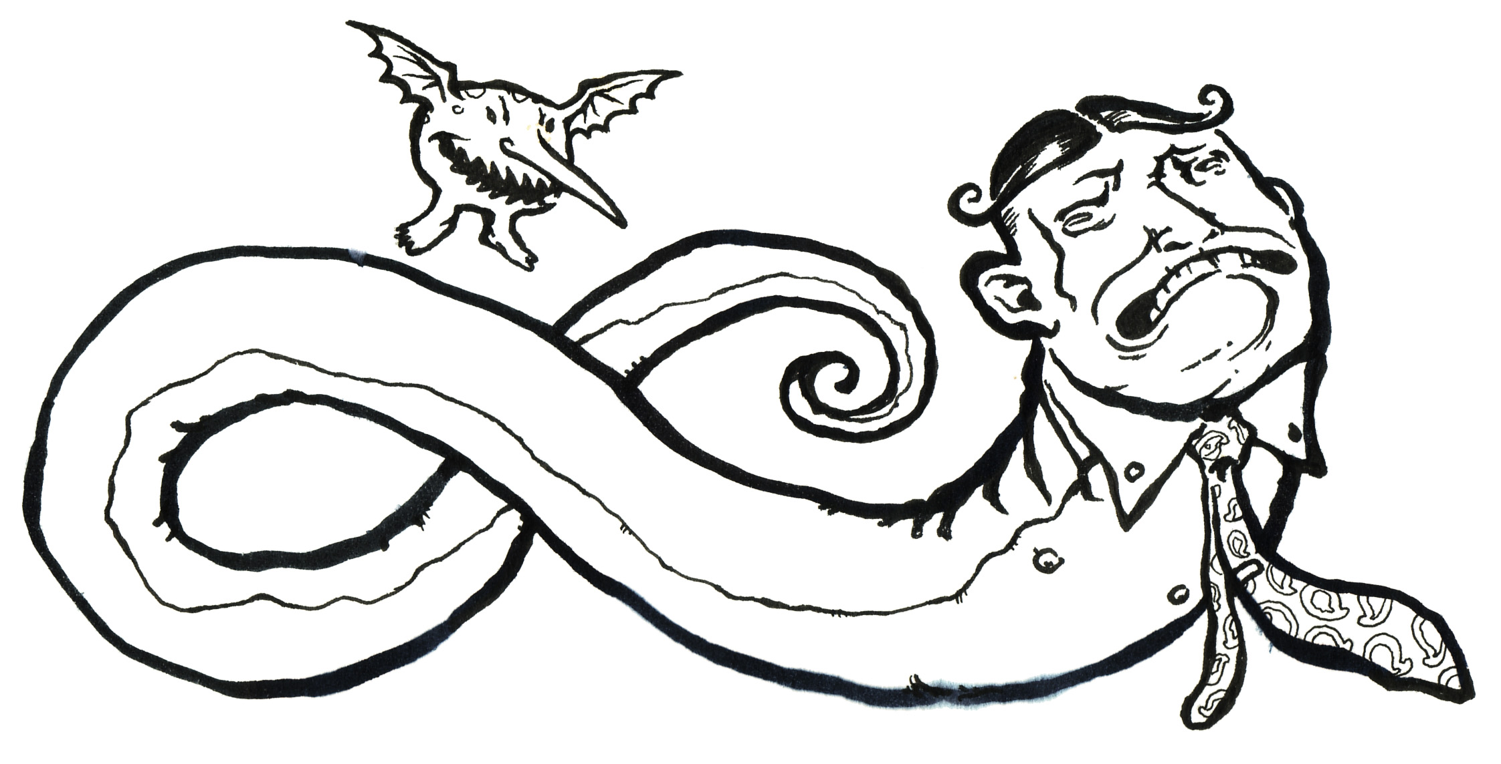
The great left-hander/eccentric Rube Waddell, here pictured as a monkeyface eel. By Leighton Kelly

3. Everyone Knows This:

Everyone—from salty Cambodian sea farmer to binoculared pedestrian tourist—knows the rule: you see the birds, you cast your line amongst them. Before the Probe had screeched to a stop, I sprang pell-mell and hell-bound from it’s odiferous, wild strawberry-smelling confines, quickly tied a 2-ounce Kastmaster (with obligatory rubber worm) to the end of my 15-pound line, sprinted to shore, and let it fly.
The thick, silver, spoon sparkled in the windless sky as it described a perfect parabola whose projected arc appeared to predict a perfect landing in a pelican-less stretch of purplish swell, a peck beyond the percolating foam. (Every now and then the Monkeyface editorial machine will experiment with alliteration. This is for the dual purpose of honing our linguistic skill and testing the overall tolerance of the readership).
Normally, the big anchovy schools don’t come within a hundred yards of dry land and I am forced to stand there, rod in hand, dreaming of the lunkers lurking beneath, pushing the hapless baitfish to the surface, just beyond the casting range of my massive—though admittedly aging—Ugly Stick. But yesterday, or so I initially thought, my luck was about to change.

4. Qirki-Lushe (“kirk-ee-loosh”)

Was it the sudden violence of my whip-like casting motion? Was it the frothing intensity of my all-abiding striper lust? Hard to say, but in either case, suddenly, the largest of all the pelicans in the flock, the bull if you will, with little warning, rose pterodactyl-like from the chop and intercepted my line at the apex of its arc.
Before you judge me too harshly, know this: I, for one, am very fond of pelicans. In fact, there are few birds, (with the exception of black-crowned night heron, purple gallinule, Philippine monkey eating eagle, red tailed hawk, common mud-hen, mourning dove, seagull, kingfisher, snowy egret, turkey vulture, prairie chicken, sage grouse, the entire warbler clan, pelagic cormorant, least bittern, peregrine falcon, humming bird, and common rock dove) that I take greater inspiration from.
This is not some beige, Robert Bly-induced nature loving sentiment but a deep cultural appreciation whose outward manifestation—a hairy, calcified obtrusion in my lumbar spine—forms one of the great physiological peculiarities of my race. To the Chinese, his epicanthic fold, to the Negro his wooly hair, to the Irish his impregnable liver, to my people the lumbar-sac (or qirki-lushe—literally: pelican-back).
Do not mistake the cavalier tone of the Monkeyface News (a splendid little outdoor magazine of vast ecological insight) for a lack of genuine concern with the plight of our native and non-native fauna. Chances are, if you are reading this, you do not belong to my handsome tribe of congenitally bankrupted eel mongers, tuba players and Broadway performers. Face it, despite your reservations, despite your mistrust of my sentiment, you yourself do not have a pelican growing out of your lower back like we do.

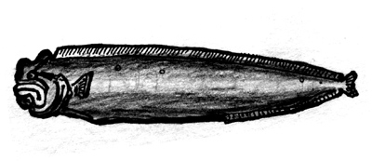
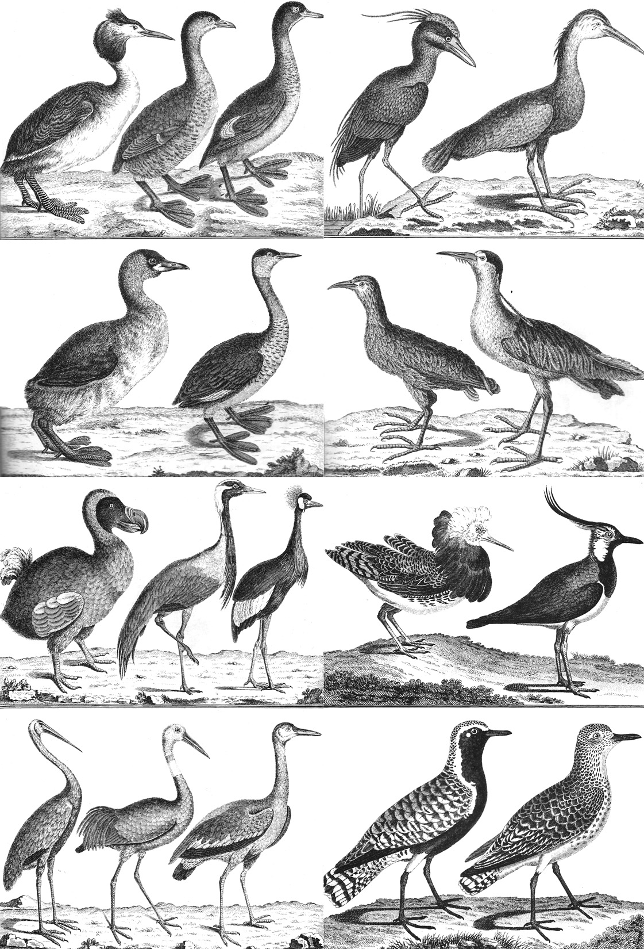
A few birds the author takes “greater inspiration from.”

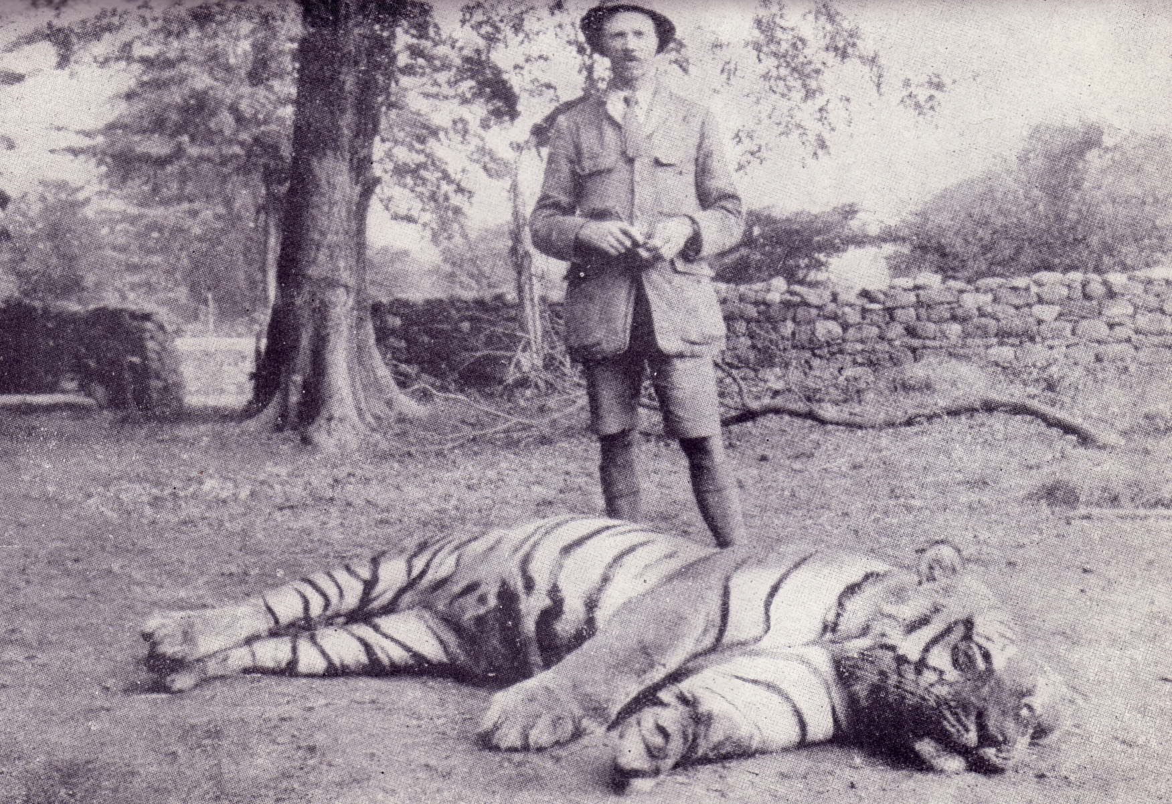
The Bachelor Of Powalgarth

Anyway, where was? Tell me, what do you do? What in the name of Christ do you do when you accidentally ensnag a beautiful, ostrich-sized, amphibious creature in your fishing line? Expediency and decorum might seem to call for a quick and well-timed snipping of the line. But think about this for a minute. The poor beast is flopping and falling, splashing and squawking, in short: panicking. As soon as you clip that line (from your position on shore) he’s going to tangle himself in its excess—and that will be the end of him. However, if you hold onto the rod, keeping the line taut, you will, (at the risk of looking like you are trying to do him harm) prevent the bird from further entangling himself.
To make matters infinitely worse, as you weigh these miserable thoughts in your guilt ridden (and pelican loving) conscience, a small crowd of onlookers, all clad in beige Nature-Conservancy fleeces, and blue Gortex, L.L. Bean wind breakers has fallen upon you in this, YOUR LOWEST MOMENT AS A HUNTER-GATHERER.
“What are you doing?” They cry.
“Why are you killing that poor pelican?” They blabber.
“The pelican is a protected species!” They protest.
“Are you proud of yourself?” They chime as one.

4. Thank God For Cambodians

Well, it was all looking fairly bleak—hopeless even. After five minutes the pelican was no less ensnared than it had been at the advent of the mishap. Initially, I tried to use the line as a sort of lasso to guide him towards the small outcropping of rocks to the immediate North of me. Then, when this failed, I attempted to unloop the line from around his throat by a series of spastic circular gestures, all the while humming the simple melodies of my people—a gentle race of pelican lovers and furniture restorers.
Needless to say, none of these tactics met with even the slightest degree of success, and, as the day wore on, and the minutes passed into hours, I began to lose all hope of a happy conclusion to this freakish scene.
There were however two factors working in my favor. One: I happened, (as is my wont while fishing the California intertidal) to be wearing my full-body, wet suit. And Two:

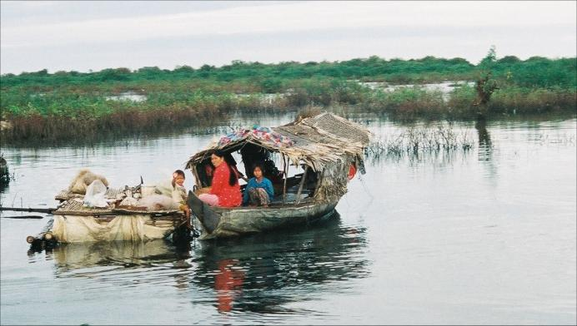
Honorable descendants of Angkor Wat

there was, (no less than 50 yards from my position near the rocks) a small family of
emaciated Cambodians watching with a vague interest as I struggled against the considerable obstacles detailed above.
Anyhoo, despite the slings and arrows flung at me with wild abandon by the aforementioned throng of beige-fleeced waisichus, I managed to indicate to the Cambodian family (by means of universal hand gestures and bleatings) my need for assistance. Instantly, a handsome Indo-Chinese fishwife materialized before me, and, exuding the vague sense that she had been through this procedure before, had commonly assisted in this type of pelican-untangling activity, reached out and grasped my squack pole (see Paczkowski’s definition). Then, with a brief and businesslike wink of total confidence, this squat, unsmiling, 50-year-old, former sea-nymph belched something in her garbled language of clicks and yowlings, and sped me towards the tumult of the seas.

5. Into The Surf I Plunged

Into the surf I plunged—the pelican increasing the violence and desperation of his struggles as I drew nearer. Hand over hand I pulleyed myself along the monofilament trail, till, treading water and besieged by foam, I found myself within arms-reach of the hostile, unappreciative behemoth.
Let me assure you, oh gentle reader, you have never appreciated the sheer size and formidability of the pelican till you’ve attempted to untangle him from your fishing line while treading water in a pounding surf in full view of an entire beachful of angry, beige nature buffs. Jesus Christ. He kept snapping at me. I do not think I am exaggerating when I tell you that his head was about the size of an average alligator’s. In fact that’s exactly what a pelican is—in a way—a great, white, winged alligator.
At length, I determined that the line was looped but once around his gorilla-sized shoulder (this was good news). However, in order to free him from the tangle, I would need his full cooperation, and, quite understandably, he was none too keen on providing me with it.
Round and round I swam! Every time I’d raise my hand up out of the water the dirty motherfucker (I use these words for descriptive purposes only) would paddle forward and attempt to spear my eye with his monstrous beak! I must have been out there for twenty minutes, dodging, paddling, freezing, getting pounded by an occasional breaker and humming the sweet, cheerful uplifting songs that my people, after eons of a strained yet respectful coexistence with these terrible birds, often sing to calm ourselves, ease the malevolent pelican spirits, ingratiate ourselves to them.
In the end, I grabbed the line, moved my hand as close to his spear-like proboscis as I dared (two feet?) and snipped it off at a place where I figured he’d be able to work his way out of it in a few hours. The job done, I then waded to shore, staggered back to my bivouac beneath the sandy cliffs and collapsed in a crumpled heap of woe, only to awake an hour later with the pelican gone and my priceless Mitchell Garcia firmly planted in the sand at my feet—like the very flag at Iwo Jima —proclaiming to all who passed, that here lay a man infected with a particularly virulent strain of squack.
Certainly, drowning while trying to save a pelican, caught in one’s own line, with a stalwart Cambodian fishwife man-hauling one’s own ugly stick, in front of an irate audience of frowning Sierra Club members will have to factor into the new and updated definition of this ever changing, all encompassing term.

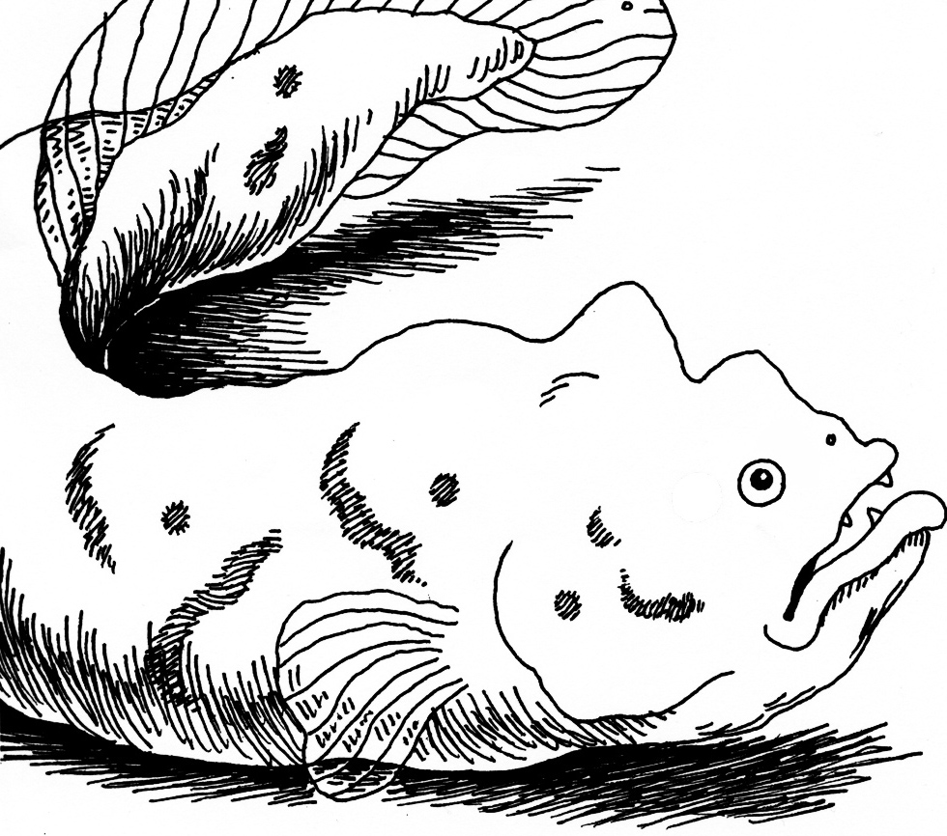
The ubiquitous “Rock Salmon,” Cebidichtus Violaceus.
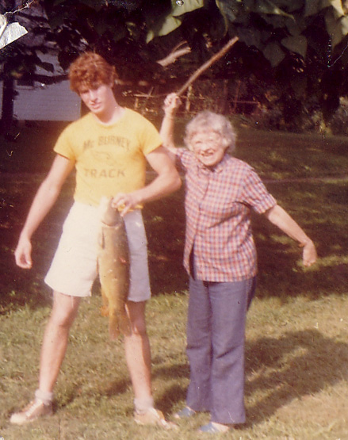
The author, in his youth, with grandmother and 10-pound carp.

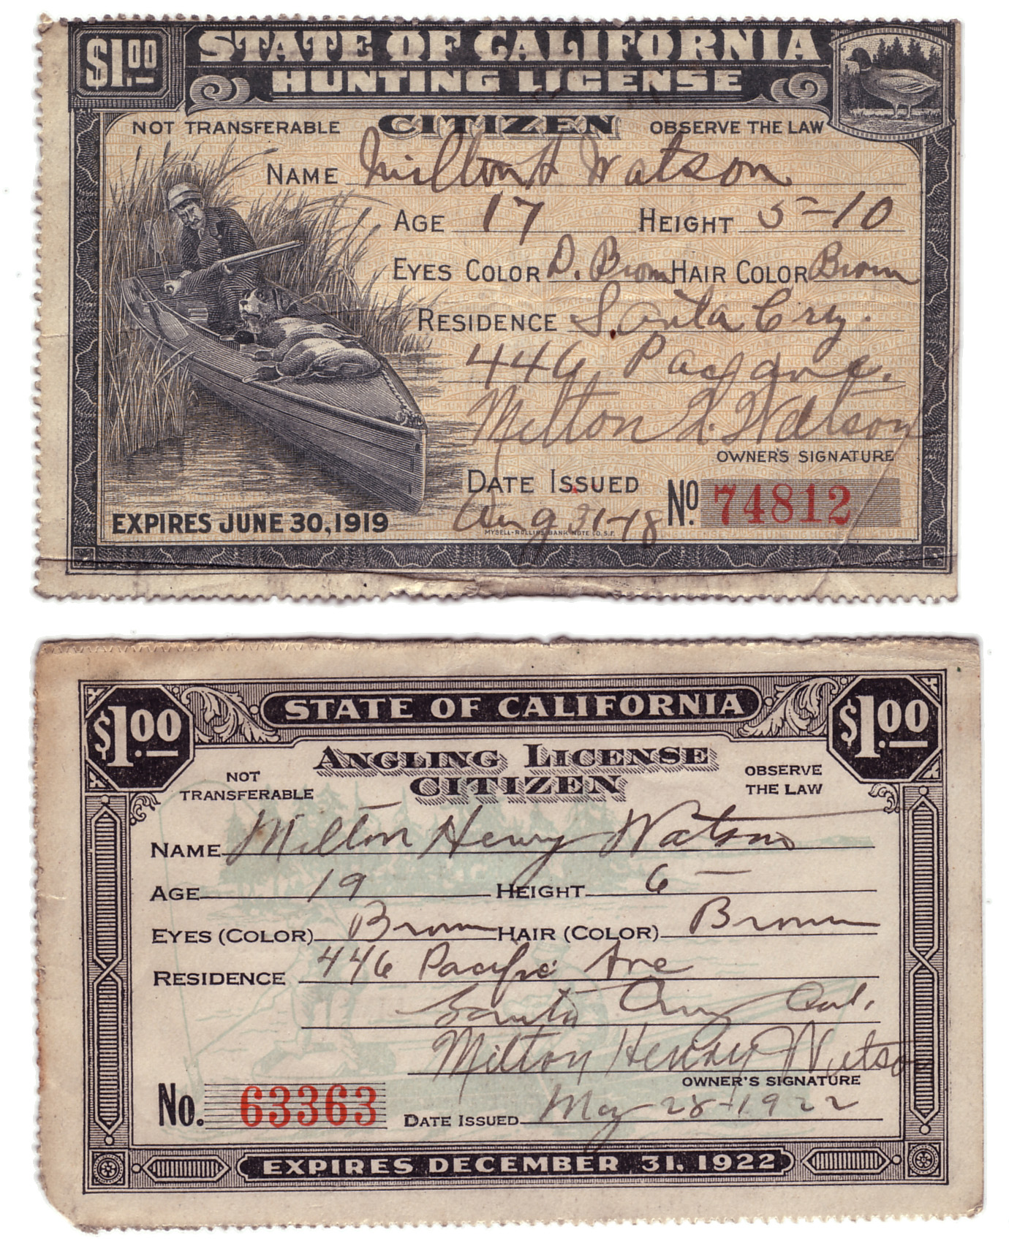

A legacy of squack: the author’s grandfather’s fishing license, circa 1920

Part 3
Thoughts on the Evolution of Eels and Men

There has been much controversy in recent years over C.F. Hibben’s seemingly misguided assumption that the monkeyface eel is related to several of the lower primates, especially the lemurs, aye-ayes and tree shrews of Madagascar. Although admittedly problematic Dr. Hibben’s evolutionary classification scheme is firmly rooted in the basic precepts of such giants as Linnaeus, Lamark and Louis B. Leakey (see Vol. one, Ch 16-19, pp 386-478, “The Big L’s ”). However, it becomes increasingly evident through a detailed reexamination of his 311 page “List of Rules,” (Vol. 5, Ch. 17, pp. 499- 810) that the author was not concerned with a mere regurgitation of existing evolutionary theories, but with the total invention of a broader more wide ranging system (or group of systems) that could be applied not only to the world “as it actually is,” but to “more theoretical planes of existence,” and “zones of ignorance and appearance,” (pp 762-781) whereby the world can only be judged and articulated by laws that apply to its superficial realities. In other words, the monkeyface eel resembles a monkey, (possessing a fully articulated prehensile tail and displaying a marked predilection for squid and other “soft food sources”) and so, on a purely theoretical level, IS a monkey—albeit of a rather tubular, aquatic and furless variety.
Many of Hibben’s most virulent detractors (Hoeller, DeSelby, Hatchjaw, Shade) point to the “List of Rules,” as evidence of his moral and psychological deterioration. Charles Kinbote in his wild, nonsensical The Zemblan Epoch, goes so far as to imply that Hibben’s List may, actually, have been authored by one of his ward mates at the solarium in Wels where he is known to have jotted down at least part of the initial abstract (Kinbote, The Zemblan Epoch, p. 12). Indeed, given Dr. Hibben’s total abhorrence for “the servile tasks” (Vol I, p.3, Letters) of editing and rewriting it is—however improbable—at the very least conceivable, that he may not have noticed this cumbersome, 311 page list stuck into the middle of the otherwise poignant (if at times arcane and ponderous) volume # 5. We simply do not know.

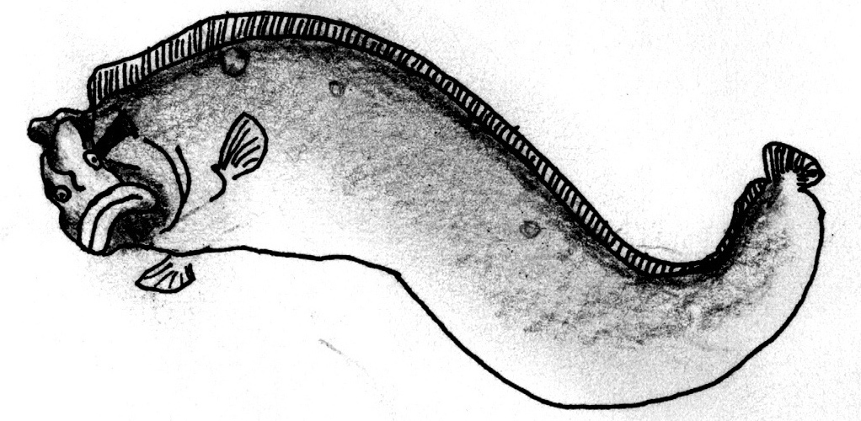
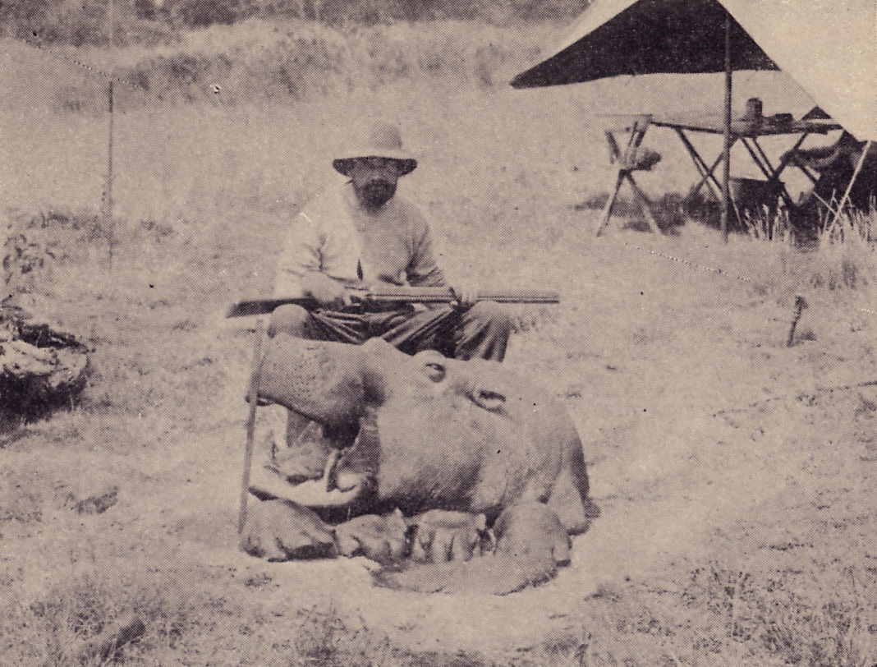
“We simply do not know.”

What we do know, however, is that despite (or maybe because of) it’s regrettable title—More Notes on My Savage Wife—Volume 5 of Hibben’s masterpiece: The World Of Anana: Eels And Identity Among The Primitive Tribes Of Middle Caledonia, remains to this day one of the most important if untapped compendiums of pure abstraction known to science.
As with all serious intellectual endeavors what we gather from “the list,” will in no small part be determined by what we ourselves bring to it. It strikes this author as callous and mean spirited to discount Hibben’s List as the work of a raving madman or as a mere chunk of disparate and meaningless words thrust into the middle of his manuscript, when he wasn’t looking, by some crazed inmate at the solarium in Wels. To imply that Dr. Hibben was so far gone that he would not have noticed the sudden arrival of 311, 12 by 17 inch sheets of white paper written in an unfamiliar hand, and forcibly shuffled into the main body of his very own magnum opus, (a work of such sheer size and substance that it outweighs the entire Britannica series by an astonishing 214 literary pounds), is tantamount to charging the tortured genius with a base and unbridled stupidity.
In short, this endless List of Rules, is a very good list; within it lie some of the most fundamental principles of the entire Hibbenaiea. If it is at times unintelligible, confounding, and crude (certainly the “pages of Eros,” and all but a few of the 379 “glandular poems” are in poor taste) the responsibility is on us, to reinterpret it, to search for its hidden meanings, and to grasp its tubular structures independent of the criticisms levied upon it by a group of petty, sour faced, pipe smoking intellectuals of little or no historic importance.

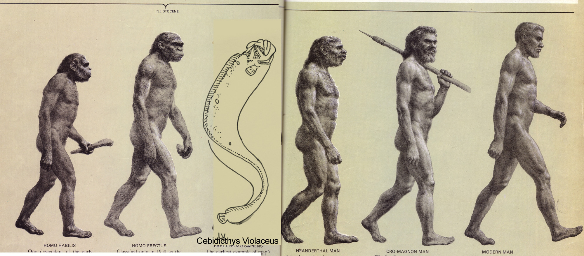

Hibbens’ Problematic Evolutionary Sequence

Part 4
Trading Eels For Salmon -or- Fattening Frogs For Snakes

Last year I began trading fresh live rockfish, monkeyface eels and cabezon for fresh dead salmon, halibut and shrimp at a certain fresh Meat Market on Mission Street. The reason a perfectly sane fishmonger would be willing to trade high-end fish meats for “lowly” bottom dwellers like Monkeyface eel, rock cod, and cabezon is simple: live fish can be preserved indefinitely in a saltwater tank, whereas, after a few days that stack of juicy $5.99-a-pound salmon fillets is going to be thrown out (if nobody buys it) with the trash.
One day last winter, while bait shopping for squid, I was approached by the bright-eyed owner of said Mission Street fish market and asked what kind of fish I was “going to catch today.” I briefly described the quarry: monkeyface eels, rockfish, cabbies. He squinted and smiled as he visualized his crab tanks loaded with living flesh, and, low and behold, a deal was struck! Whatever I brought him—as long as it was still alive—would be matched pound for pound in halibut and salmon steaks.
Loyalty to the noble species of the California intertidal notwithstanding, this struck me as a fair bargain. So I headed out that morning with a song in my heart (Paddy Lay Back) and endeavored to capture as many eels and rockfish as sanity and providence would allow.
Needless to say, by the end of that fateful day I had hauled in two buckets full of eels, rock cod, greenling and cabezon and after a quick and happy transference of these creatures to the live tanks at Fresh Meat, I had gained for my own coffers, more halibut and salmon than a squadron of galley slaves could consume after 12 months’ heavy rowing.
It all seemed so easy, so perfect… so honest… so good.

- And Then I Came to Know the Meaning of Sin.

Over the course of the next week I walked, or drove, or rode my bike past Fresh Meat Market probably twice a day. And, as the tank was (and to this day remains) positioned in the window in front of the store, I had the unique privilege of looking in on the fish I had captured and delivered into Auschwitz (Fishwitz—to partially coin a phrase). After two days no one had yet purchased a single one of my victims. Won’t anyone put them out of their misery? I whined (to myself, in my lonely, soul searching moments). Still, after three days, only two of the rock cod were gone and those that remained had begun to languish in the mean, algae encrusted prison. The scales of their once vibrantly camouflaged skins had begun to fall out, a milkish, glaucomic decoupage had settled upon their jaundiced eyeballs, and the movements of their tails and fins appeared sluggish, death riddled, miserable. It got so bad I stopped walking on Mission Street on my way home from work. Late at night I would awake drenched in sweat, from tumultuous purgatorial nightmares.
After five days the only remaining captives were a hefty cabezon and two python-sized eels. And then, late one night, after drinking my fill in front of the uniquely unsympathetic bartenders of The Latin American Club, (no wonder I never go there) I stopped by and stared in through the barred, gated windows, of “Fresh Meat.” The place was closed, the lights off, the eels facing out towards Mission Street. I stared in at them. They stared back, aping me, with angry, simian faces.

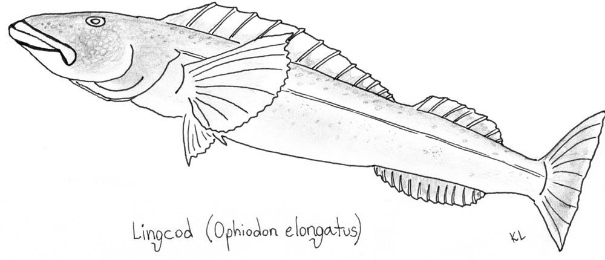
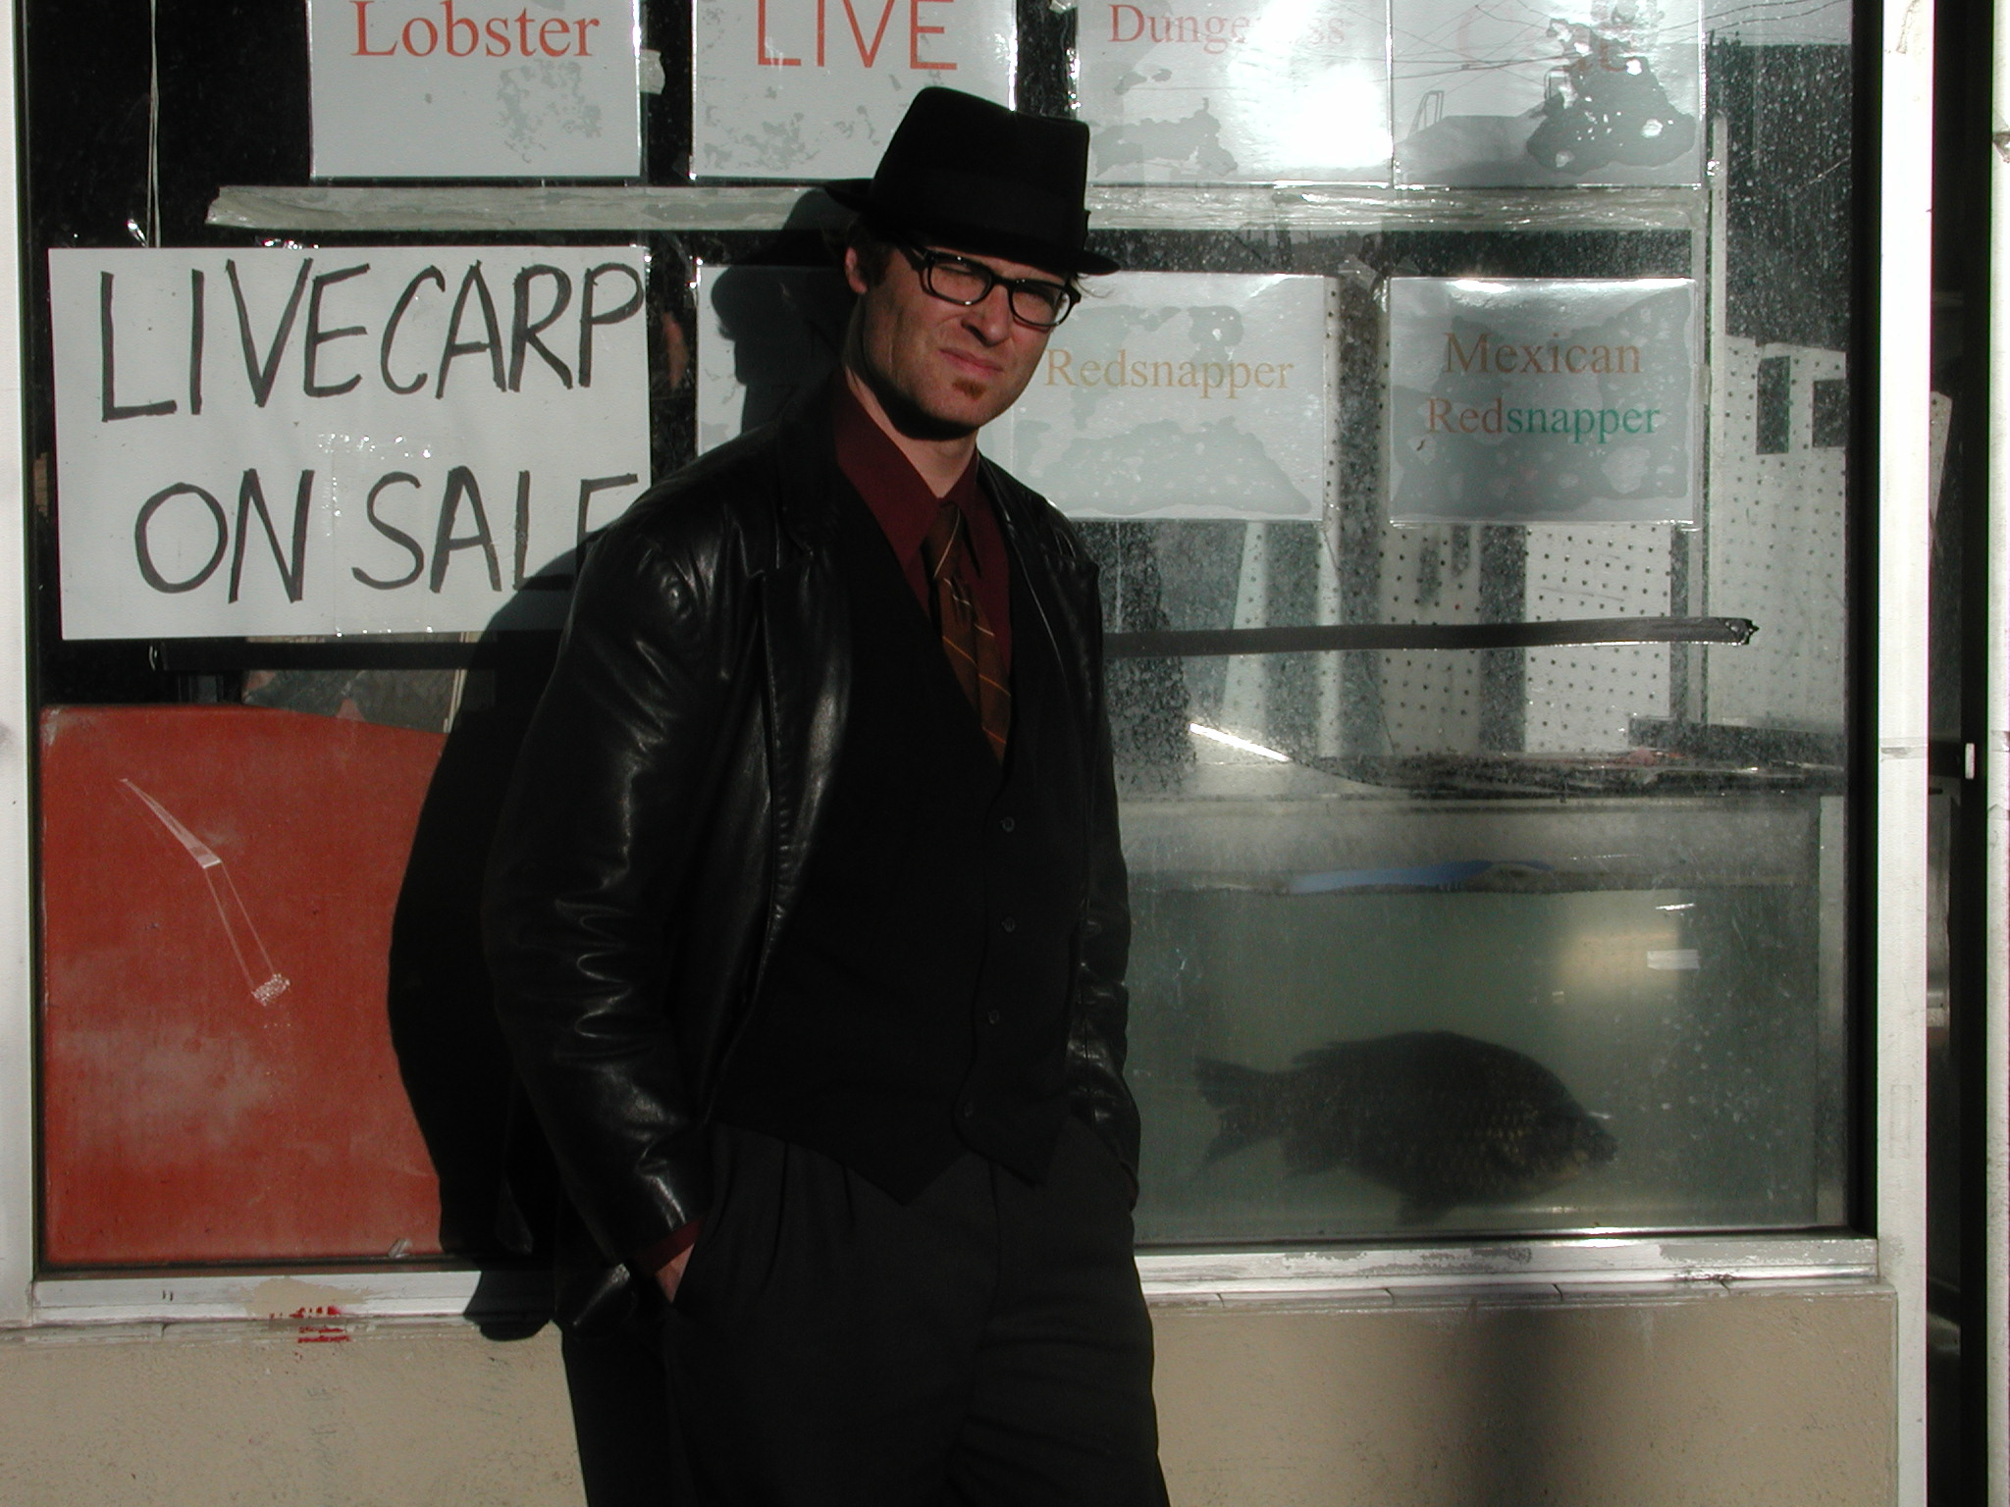
Mission Street Death Tanks

Yes, it was I who brutally ripped these hapless creatures from the pristine tide pools and briny kelp beds of their native shores. Yes, it was I, the man who bears their name in his e-mail address, who sings their praises in his (scurrilous) newsletter (of far reaching importance). Yes, dear reader, it was I (who should have known better) who had perpetrated this deed of immense evil, having betrayed the one creature that I value above all others -- sending him, for a few pieces of silver salmon flesh, straight to the 9th level of piscatorial hell.
Needless to say, it was with bleary eyes and heavy heart that the author returned to his Harrison Street domicile that wintry evening, 15 months ago, and, giving in to his feeling of melancholy, forced himself to endure a few pages of Coleridge before falling into another fitful, restless sleep.

Deliverance

There is one thing I had over the ancient mariner: having blasted his albatross with a muzzle loading blunderbuss, there was, in his case, simply no bringing it back to life after the deed was done. Two of my eels, however, were still alive! So there was, even now at the eleventh hour, ample time for an act of partial redemption.
On the morning of the sixth day I entered Fresh Meat at 7am, and, having procured the two remaining eels (the last cabezon, sadly, had been purchased that morning) and placing them back into the bucket of their original middle passage, hauled them to their pristine home along the rocks south of Pescadero. Here I managed to locate the general area of their capture and after plying their gills with fresh sea water, rocking them gently back and forth in the shallows (following the proper procedures for steelhead catch and release), watched with an almost overwhelming degree of pride and inspiration as they wriggled free of my grasp and slipped back down into the briny, anemone choked holes of their beloved intertidal.



Smile for the Camera.

Part 5
Sagas Of The Fucking Sea:

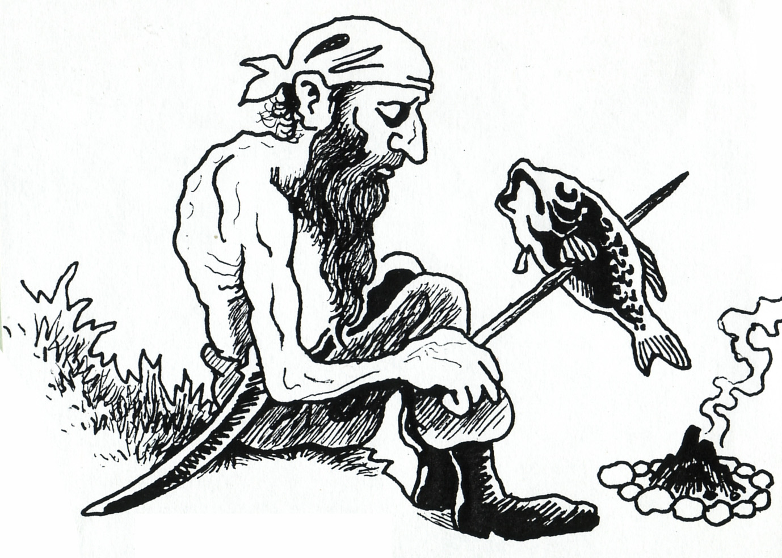
The Wreck Of The Whaleship Essex
by Owen Chase

You think you got problems? Life got you by the balls? Read The Wreck of the Whaleship Essex by Owen Chase and find a new meaning to the term shit out of luck (in this instance squack does not even apply). 2000 miles from the nearest stretch of dry land, in the nautical center of the Pacific Ocean, an 80 foot long sperm whale turned from it’s pod and “with tenfold fury and vengeance in his aspect,” rammed his massive head straight through the hull of the Essex, leaving her crew with nothing save a few leaky row boats and a month’s provision of salt tack and water.
The resulting tale of mind-numbing desperation, godlike endurance, cold hearted murder and gut wrenching cannibalism makes the Donner Party look about as civilized as a Sunday brunch at Zuni Cafe. The ultimate irony of the story is that they did not sail to Tahiti (which they could have made in a month or two from the spot where the ship sank) for fear of cannibals.
Of the 26 men who embarked on the Essex in the spring of 1837 only 7 survived to tell their tale. Chase, the first mate, (and the only survivor who actually saw the whale strike the boat), gives a spirited, eloquent and at times nauseatingly graphic account of the entire debacle. This book is a must read, and at a mere 130 pages, perfect for the bathroom. So drop everything (no pun) and get this book.
MFN Rating: 5/5 eels

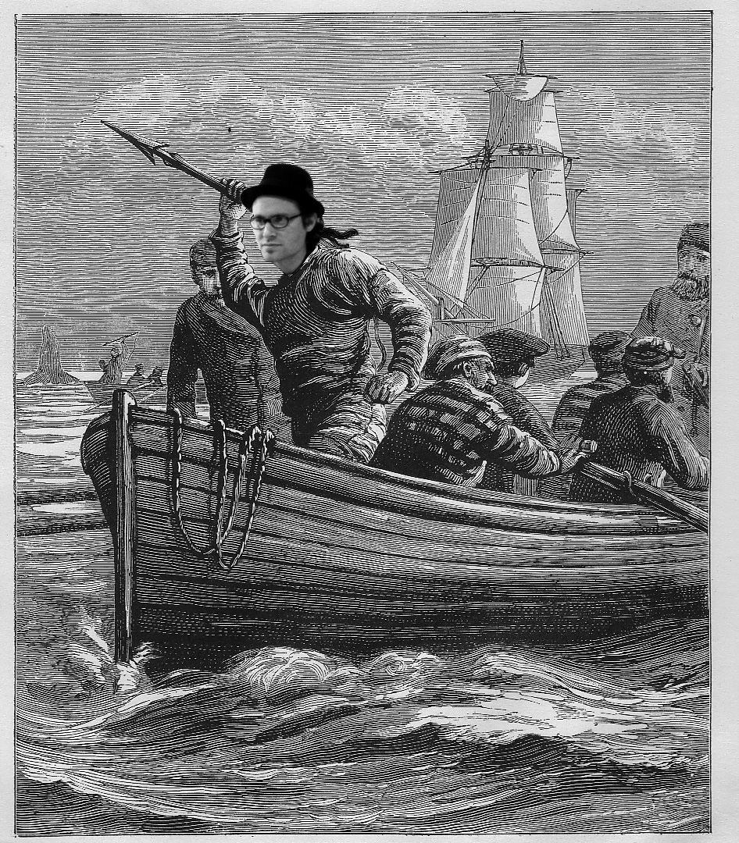
Mutiny On The Globe
by Thomas Ferrel Heffernan

Imagine Henry Portrait of a Serial Killer meets Mutiny on the Bounty. Sounds promising doesn’t it? Well, truth is, I finished this tedious, predictable, absurdly Freudian, reexamination of the dreaded Globe mutiny and decided I’d be better served to have one of my Monkeyface operatives read the sucker and review it for me -- lest I should become unkind in my subsequent review of it.
Always eager to please, Mr. C.D. Cummings, field manager of our West Coast offices, took it upon himself to contact the principle actor in the mutiny, Sam Comstock (1793—1823) and thereby present to the readership a much closer and more satisfying view of him than Heffernan was able to provide in his three hundred page diatribe.


Field Manager Cummings

C.D. Cummings:
In 1823, Samuel Comstock, boat stearer of the whaleship Globe, out of Nantucket, plotted, organized and carried out one of the most brutal mutinies in all of American nautical history, decapitating Captain Thomas Worth, (with a flensing blade while he slept) and viciously murdering all the other officers on board. Comstock then navigated the ship to the Marshall Islands, where he was eventually done- in by his fellow mutineers. Four of the crew escaped in The Globe; two were marooned on Milli atoll and the remainder were either enslaved or slaughtered by roving bands of hostile natives. The Monkeyface News contacted Mr. Comstock recently and was able to conduct the following interview.

MFN: First of all, it’s a pleasure to speak with you.

SC: Har!

MFN: Let me begin by asking what you thought of Mr. Heffernan’s
rendition of your adventures on The Globe?

SC: I think him a sot and damned fool. The book is full of heresay and untruth. He imputes my motives most basely. I’ll stove his jaw and puncture his arse, I will!

MFN: The book is drawn from various historical narratives about The Globe and your mutiny—are you saying that these testaments, including those of your shipmate and younger brother, George Comstock, are largely false?

SC: He slanders me, sir!

MFN: But each of your brothers wrote scathing biographies of you.

SC: Turncoats, liars, mountebanks and frauds—the lot of ‘em.

MFN: Heffernan traces your early life, but there is a paucity of information—excepting that wonderful scene in the brothel in Valparaiso.

SC: Aye, that was a time! The battle between the whore and the midget girl! Throwin’ the darkie off the cliff!

MFN: That’s where you met Oliver, who would join you years later aboard the Globe and participate in all of the mutineers’ most cruel and desperate acts.

SC: Aye, he was a “stout fellow,” that Ollie.

MFN: I’m wondering if you can explain to the readers the real cause of the mutiny?

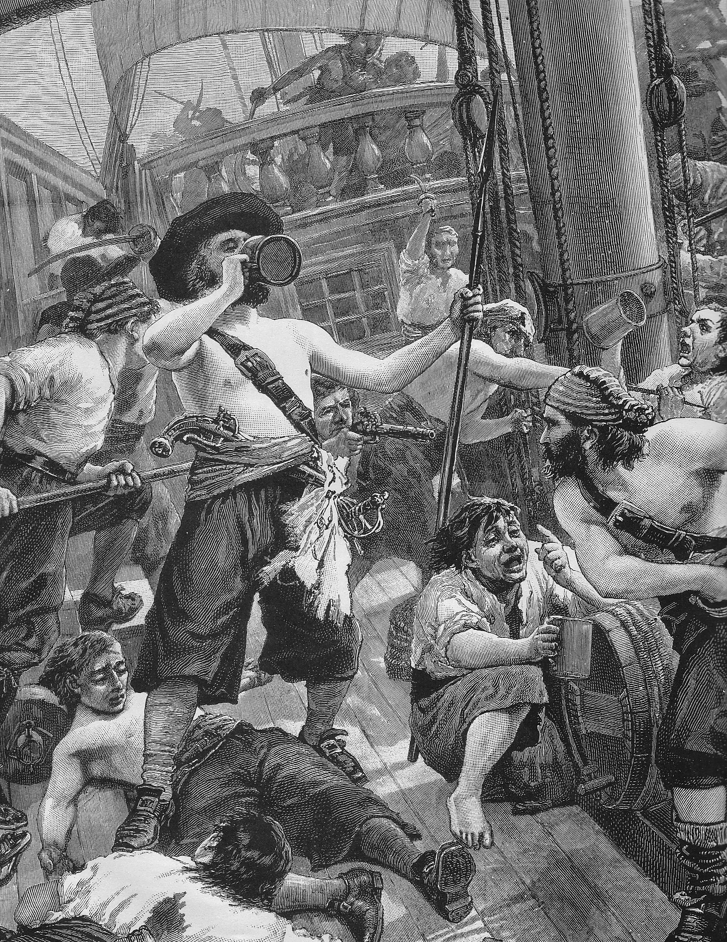
Mutineers

SC: Well… the victuals was bad…. and it’s not as we’d be given enough time to eat ’em. But the Captain, aye… Captain Worth, was… most ill-named.

MFN: Yes, we understand, but did you really have to saw off his head with a flensing knife?

SC: He was a stinkin’ tyrant, I say. And though my brother William’s book calls me “Comstock, the Terrible Whaleman,” yet look again at our bloody Captain. Why, he had precious little oil to show for his command! A blind Dutchman could’ve found more whales than this miserable wretch. And the crew was paid out by a percentage of the take, don’t forget!

MFN: Any comments on the circumstances of your own death at the
hands of your fellow mutineer, Mr. Payne?

SC: He was a scoundrel and yellow belly—but at least he was aptly
named! (Laughs). Ran me through with a sabre from knave to thrapple, he did. Got his come-uppance though, surely.

MFN: You are, of course, referring to his later career as slave, whipping boy and man-wife to a heavily muscled and tattooed Marshall Islander?

SC: Yes, I am.

MFN: What do you know of Dr. H.H. Hibben’s later work with this same group of savages?

SC: Who?
MFN: Nevermind… speak, if you will, Mr. Comstock, of the last 250 pages of Heffernan’s book, Mutiny On The Globe.


Some Marshall Islanders

SC: A dry, windless expanse… No chicks. Demon on the Water was better. Speaking of which, I’d better shove off.

MFN: One last question: what was with all the “I am a bloody man, I have the bloody hand, I will be avenged” stuff?

SC: Oh, I don’t know. Sounded fancy at the time. I was a kid, you know? I was doing the deed. I was the bloody man. Now … [eight bells calls him out]… I must go. God bless.

MFN: Any other comments on the book?

SC: Well, it’s a God awful bore after I die on page 99, but we’ve established that already.
MFN Rating: 1/5 eels

Sailing Alone Around The World
by Joshua Slocum

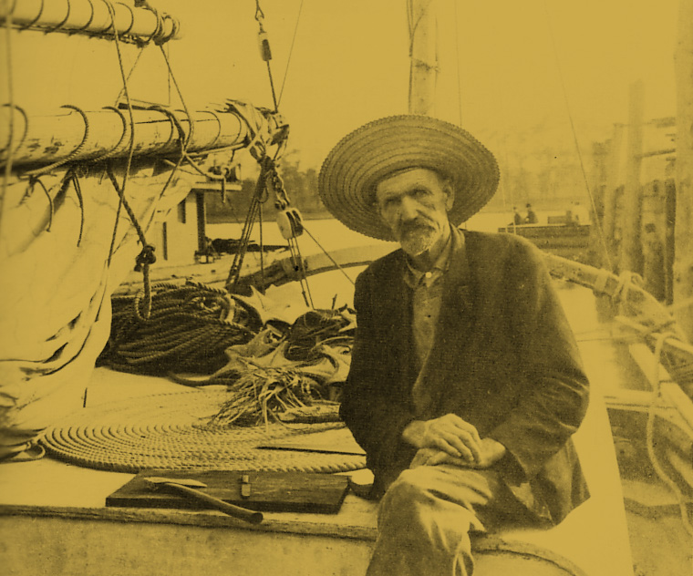
Slocum aboard his “Spray”
I’d like to thank Peter Freuchen (drop everything and get a copy of The Vagrant Viking—to be reviewed in the next edition of the Monkeyface News) for introducing me to Slocum and his masterpiece Sailing Alone Around the World, thanks Pete.
The year is 1890. After a long and storied career as sailing captain, Mr. Slocum retires to Nantucket. Several months later he feels the siren call of the sea. In his neighbor’s back yard there lies a small derelict craft, which, Slocum figures with a little TLC could become a sturdy ocean going vessel. He purchases the hulk and begins to rebuild her. After a year “the Spray” is born. The first several chapters deal with the specifications of her overhaul. The remaining chapters involve Slocum's adventures sailing the Spray around the world. Despite this prodigious feat of navigation, despite the author’s talent, skill, etc., he somehow managed to write an incredibly humble and heart warming novel. His insight into the ills of the world, the mistreatment of natives by missionaries, and his assessment of human nature are spot on and yet never preachy or tedious. Hard to believe he penned all this before the turn of the century.
Despite his kind, undemonstrative nature, Slocum was nobody’s push over. Firing shots over the heads of marauding Fuegians, spreading tacks on the deck of the Spray to thwart barefoot pirates! Facing hurricane gales off the coast of Africa and rounding the horn in a 21 foot boat!
MFN rating: 5/5 eels
Part 6:
The Making of The Monkeyface Eel Movie
(Drop everything, go to idyllist.com and watch the motherfucker)

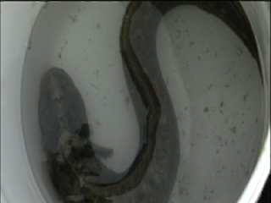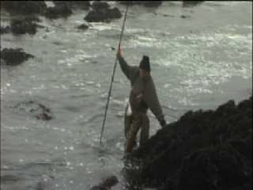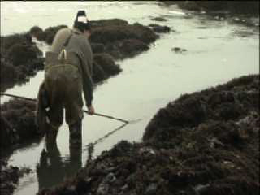
Film stills from A.P. Swearengen’s Eel Hunting, 2003

Four things you should know before you decide to make a movie about poke poling for monkeyface eels:

1. Interviewing a man (me) who is driving a VW Bug on Highway One in the rain, hurtling along at 60 miles an hour without windshield wipers, while seated backwards in the passenger seat, holding a 60 pound camera, is a tricky, uncomfortable and dangerous proposition.

2. When the camera is rolling you will squack. Billy Dance Outdoors be damned, we went out three times to the rocks below Pescadero and in the end all I had to show for it was two scrawny eels and 22 pounds of rock crabs. Oddly, the director has chosen not to include any film footage of the monstrous cabezon I hooked while the camera was rolling. Whats’up Pete?

3. It’s all about the money shot. A year later we still refuse to admit that the
eel movie is over. This is because A: Despite several medium sized eels we never caught a lunker (in other words we squacked). And the success of all fishing videos is directly proportional to the size of the captured fish (see Okie Noodling) B: Also, we never got the money shot: actual underwater footage of the eel taking the squid bait. I have recently been thinking about purchasing a tank, filling it with salt water, and keeping a few rather large eels imprisoned within it. The thought being that some day we might actually induce one of these traumatized creatures to take a piece of squid from a baited hook while the Goddamned camera is rolling.

4. The underwater cameraman/brother-in-law will be your undoing. The
problem with the underwater cameraman/brother in law is that the footage he gets (and the very idea of having an underwater cameraman to film eels in tide pools with you) will become so appealing that you will not want to finish the movie till you get more footage out of him and frankly the underwater cameraman/brother in law has much better things to do with his time—like filming sharks off the Farollons for National Geographic—than probing around in murky tide pools in search of slime covered bottom dwellers.
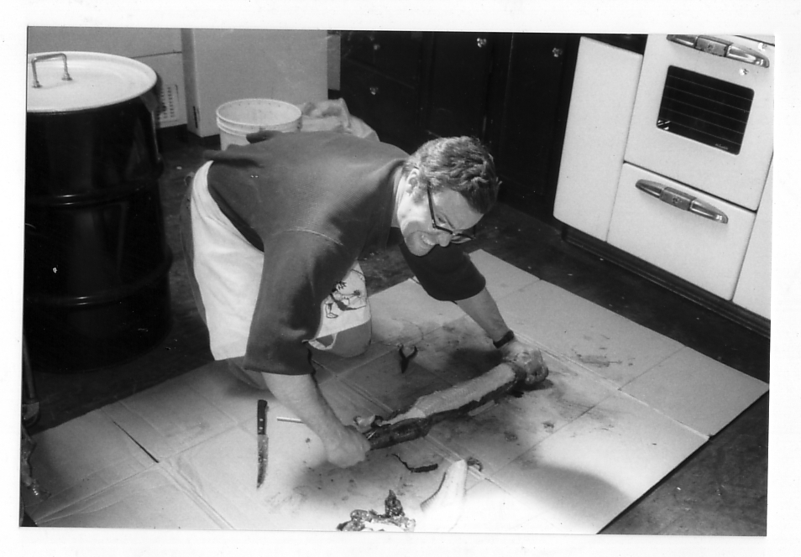
Harrison Street Eel Works: the author skins “a big ‘un”

Part 7:

The Legend of Walks-Far Woman

Right now it is 8:00pm and there are three large eel skins soaking in a brine solution on my roof. In the last two months I have captured, skinned and tanned no less than eleven lunker-sized eels. If you are holding one of the limited edition copies of the Monkeyface News, you have, no doubt, stopped and considered the small patch of Monkeyface eel skin on its cover. You have possibly remarked on the tough, papery quality of it, and held it up to a light to check its translucency. The Monkeyface News book binding works and eel skin tannery will stop at nothing to bring you the finest quality eel skins and book covers.
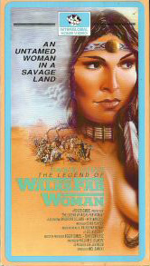

10pm. Just spent another hour scraping the mucous off the inside of the pelts and into the drain in my kitchen sink. Above my desk here at MFN head quarters there is a photograph of Raquel Welch in the title role of the 1979 made-for-TV classic: The Legend Of Walks-Far Woman. Poor Raquel she looks so unhappy on her knees, scraping the meat off this gigantic buffalo pelt. Let it be said: I feel her pain. The women of hunting-gathering tribes got a raw deal for sure. Then again they didn’t have the added impediment of working in a cramped Mission district kitchen, with scowling roommates walking back and forth. No, in fact, to the contrary, early anthropological records indicate that tribal women received no small amount of social support for their all-important de-fleshing activities, and had the leisure of working outdoors on the open plains of Wyoming (where they could spread the buffalo skins in the sun and not worry about fucking up the sink and clogging the drain with eel snot).
Now it is 8:00am, 12 hours later. My sleep was filled with revolting, mucoidal nightmares. My pipe tobacco now owns a slight, oceanic flavor—effervescence of low tide, we’ll call it. (*Note: The Monkeyface editorial machine does not advise pipe smoking while skinning eels).
Anyway, after bashing their heads with a club, skinning them, sawing off their skulls (yes, I boil down the skulls and save the otoliths and jaws) filleting the pink flesh from the still quivering flanks, disposing of the malodorous offal, and wiping the gore off my long Swedish flensing blade, I turned to go back inside MFN head quarters (through the living room window, mind you) and beheld a group of about a half dozen Mexican children all staring at me from the adjacent apartment building with open mouths and wild, horrified expressions on their tiny faces. I smiled and waved a bloody hand at them, but as of this writing, none of these traumatized youngsters has yet waved back.
10am. Halleluiah, the eel hides are soaking. After marinating in a heavy brine solution (one pound of salt per half gallon of water) for five days, I will strain them through a special colander (I italicize the word lest my roommates come to suspect that I have used our communal spaghetti strainer for this grim snot removal process), into the toilet bowl. The glue-like residue will be flushed away immediately, the skins rinsed (in my bathtub) to remove any excess phlegm, and then soaked in clean water overnight to leach out the salt. Finally, after leaching, the hides will be stretched on a greased plank, tacked down, doused with powdered borax, and left in the sun for a day. At the end of this borax stage they will be rinsed again (on the board) and brought back onto the roof for another day of non-boraxed drying. When all moisture has evaporated (and this time of year that can take up to four days) I will have a collection of grey/translucent, cardboard-like, eelskin sheets—somewhat workable and tough as beef jerky. I recently called WASCO taxidermy center in Georgia and asked them if, through all of my inexpert efforts, I had managed to create something akin to real leather. I was informed that what I had actually produced was a specie of rawhide or “dry preserve.” I asked what I would have to do to turn my eel hides into true leather and the guy at WASCO said that fish skin is a tricky thing to tan. He said that any time you make leather, whether it is fish skin, reptile skin, or bison skin the end result is always, “10 percent chemical and 90 percent hard work.” Later, I discovered this unfortunate sentence in a website on deerskin tanning: “Often, Native American women would soak their hides in urine and chew on them to allow the natural enzymes of their bodies to help soften the skins.” I wonder if this was part of Raquel Welch’s sense memory approach for Walks-Far Woman—pissing on a buffalo pelt and then chewing it?
Which reminds me… it’s odd, at the Odeon last week I had three separate people suggests that I piss into my eel-tanning bucket and let the “natural enzymes” do their thing. (I’ll only do it if one of these self-professed modern primitives agrees to masticate the skins afterwards). The truth is, despite my callous exterior, there really is some shit I will not force my housemates to endure. It’s bad enough that I have all these heads, carcasses, skins and buckets full of noxious chemicals outside my living room window, without adding festering pools of my own urine to the mix.

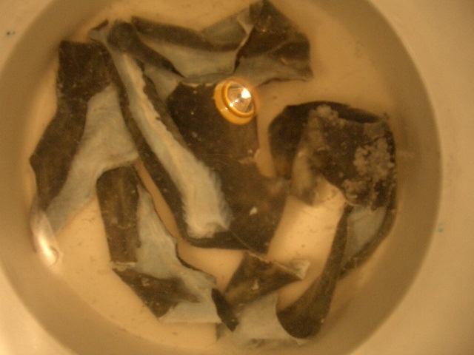

The hallmark of eccentricity: nighttime eel tanning on the
roof of MFN headquarters: Harrison Street, SF.

Poem # 236 b

Eel Snot In My Drain

Oh putrid grease
From putrid beast
Come thither to my drain
And let thou raw albumen slops
Come dripping down like rain
Oh see the cheery reverend,
come dancing from his room
He casts a glance into the sink
—his eyes now filled with gloom

The putrid grease!
The snot filled sink!
The rooftop’s blood and gore!
The fearful eyes, and woeful cries of the Mexicans next door!

Oh putrid grease
Oh slimy snot
Oh skins with chunks of meat!
Oh brutal hand
Oh desperate man
Your world is not complete

Without the skins
To house your books
To hold dear Eric’s rapture
To give excuse
To eels’s misuse
And justify their capture.

Lord knows the meat is foul enough
And tends to be quite rubbery
Like chubby whales
Or low-born snails
It’s texture ‘tis most blubbery

Oh putrid grease
From putrid beast
Come slither down my drain
And let thou raw albumen slops come dripping down like rain
Come dripping down like rain

California Hook and Line Records for Near-shore Fishes:

Cabezon: 23 lb, 4 oz.
Caught by one: Bruce Kuhn,
LA., CA. 4/20/58
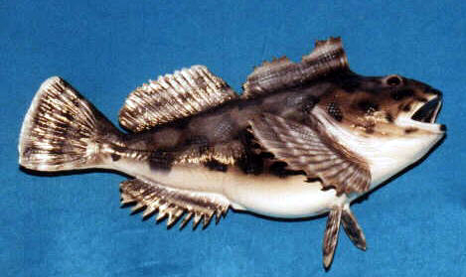

Monkeyface Eel: 4 lb, 12 oz.
Caught by one: Larry Gates
(You can run, Gates, but you can’t hide)
Marin County, CA. 6/16/02
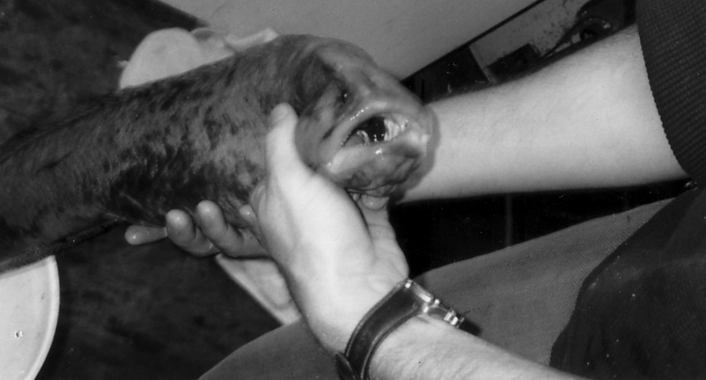

Lingcod: 56 lbs (Goddamn!)

Caught by one: Carey Mitchell
Crescent City, CA. 7/12/92
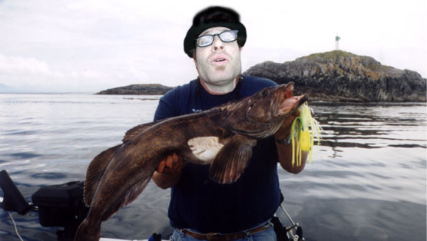

Part 8:
Best Low Tides (minus tide + reasonable sunlight), Monkey Face Hunting Grounds, Central California Coast, Summer 2004

Any tide lower than 0.0 (ie: the tides listed below with corresponding negative numbers) are called minus tides. They are caused by added swell at the center of the ocean from the extra gravitational force exerted during full and new moons. They are not necessarily the greatest times to fish, but because there is more of the intertidal exposed, your chances of catching eels, cabezone , rock cod, et al are greatly increased. Unless fishing an extremely early minus tide, plan to be standing in the water with the squid on the hook at least 2 hours before the time listed below. The Monkeyface Editorial machine suggests a light wet suit but leg waders are also acceptable. For squid: go to Fresh Meat Market on 23rd and Mission. Bon Voyage, and happy poking! (Be sure to check Fish and Game website for rockfish, cabezone, greenling and lingcod closures).

May

DATE DAY TIME LOWNESS
05/04/2004 Tue 05:48AM -0.9 L
05/05/2004 Wed 06:33AM -1.4 L
05/06/2004 Thu 07:21AM -1.7 L
05/07/2004 Fri 08:13AM -1.7 L
05/08/2004 Sat 09:08AM -1.5 L
05/09/2004 Sun 10:09AM -1.2 L
05/10/2004 Mon 11:14AM -0.8 L
05/11/2004 Tue 12:19PM -0.5 L
05/12/2004 Wed 01:18PM -0.1 L

05/13/-16/16 – Squack Week (MFN Editorial Machine Suggests Waiting Till The 17th For All Serious Tide Pooling Endeavors).

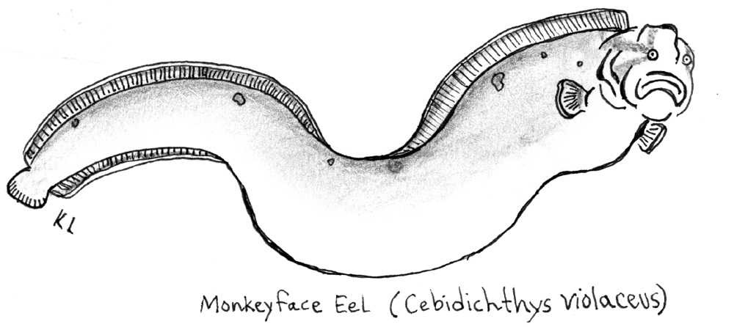
The Quarry, Bucketed

05/17/2004 Mon 05:26AM -0.3 L
05/18/2004 Tue 06:00AM -0.6 L
05/19/2004 Wed 06:33AM -0.7 L
05/20/2004 Thu 07:07AM -0.8 L
05/21/2004 Fri 07:42AM -0.8 L
05/22/2004 Sat 08:20AM -0.7 L
05/23/2004 Sun 09:01AM -0.5 L
05/24/2004 Mon 09:47AM -0.3 L
05/25/2004 Tue 10:37AM -0.1 L

June

DATE DAY TIME LOWNESS 06/01/2004 Tue 04:46AM -1.0 L
06/02/2004 Wed 05:32AM -1.6 L
06/03/2004 Thu 06:20AM -2.0 L
06/04/2004 Fri 07:09AM -2.1 L
06/05/2004 Sat 08:01AM -2.0 L
06/06/2004 Sun 08:54AM -1.7 L
06/07/2004 Mon 09:49AM -1.2 L
06/08/2004 Tue 10:45AM -0.7 L
06/09/2004 Wed 05:04AM -0.1 L

06/10/-06/15 – Squack Week (MFN Editorial Machine Suggests Waiting Till The 16th For All Serious Tide Pooling Endeavors).

06/16/2004 Wed 05:43AM -0.7 L
06/17/2004 Thu 06:16AM -0.8 L
06/18/2004 Fri 06:50AM -0.8 L
06/19/2004 Sat 07:24AM -0.8 L
06/20/2004 Sun 08:00AM -0.7 L
06/21/2004 Mon 08:37AM -0.6 L
06/22/2004 Tue 09:16AM -0.4 L
06/23/2004 Wed 09:56AM -0.1 L

July

DATE DAY TIME LOWNESS 07/01/2004 Thu 05:19AM -1.7 L
07/02/2004 Fri 06:09AM -1.9 L
07/03/2004 Sat 06:57AM -1.9 L
07/04/2004 Sun 07:46AM -1.7 L
07/05/2004 Mon 08:34AM -1.3 L
07/06/2004 Tue 09:21AM -0.8 L
07/07/2004 Wed 10:09AM -0.2 L

07/08/-07/14 – Squack Week (MFN Editorial Machine Suggests Waiting Till The 15th For All Serious Tide Pooling Endeavors).

07/15/2004 Thu 05:24AM -0.4 L
07/16/2004 Fri 05:59AM -0.5 L
07/17/2004 Sat 06:31AM -0.6 L
07/18/2004 Sun 07:03AM -0.6 L
07/19/2004 Mon 07:35AM -0.5 L
07/20/2004 Tue 08:08AM -0.4 L
07/21/2004 Wed 08:41AM -0.1 L

07/22/-07/30 – Squack Week (MFN Editorial Machine Suggests Waiting Till The 31st For All Serious Tide Pooling Endeavors).

07/31/2004 Sat 05:55AM -1.5 L

August

DATE DAY TIME LOWNESS 08/01/2004 Sun 06:40AM -1.4 L
08/02/2004 Mon 07:23AM -1.1 L
08/03/2004 Tue 08:05AM -0.6 L
08/04/2004 Wed 08:47AM 0.0 L

08/05/-08/13 – Squack Week (MFN Editorial Machine Suggests Waiting Till The 14th For All Serious Tide Pooling Endeavors).

08/14/2004 Sat 05:33AM -0.2 L
08/15/2004 Sun 06:04AM -0.3 L
08/16/2004 Mon 06:34AM -0.2 L
08/17/2004 Tue 07:03AM -0.1 L

08/18/-08/28 – Squack Week (MFN Editorial Machine Suggests Waiting Till The 29th)

08/29/2004 Sun 05:34AM -0.8 L
08/30/2004 Mon 06:14AM -0.6 L
08/31/2004 Tue 06:53AM -0.2 L
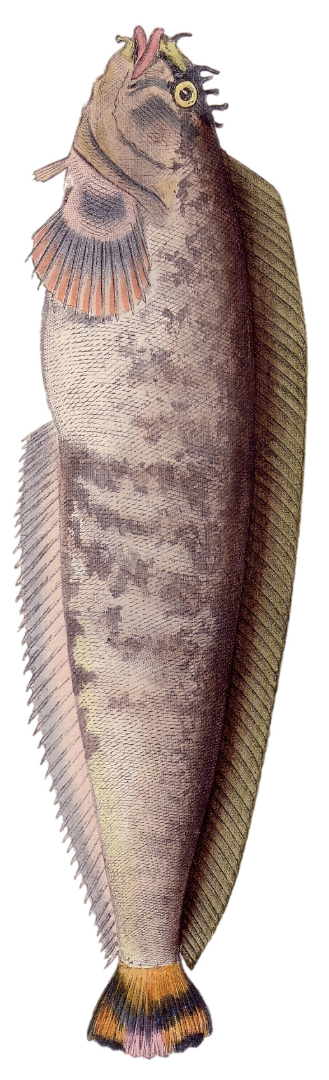
Hibben’s Prickleback (Actual Size)

Map of Lombard Traditional Fishing Grounds (contested by Poland)

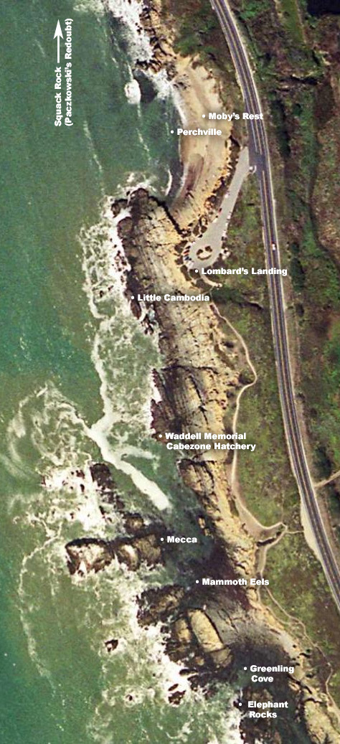

A slimy intertidal kiss to the following stout fellows:

Eric Roddenbeck (at stamen.com) for countless hours of dutiful layout, scanning and design work on this bitch, and for saying: “Do you really think you could turn them into book covers?”

Michael Larry Henderson (aka: Reverend Wupass) for mixing, recording and engineering the cd. And for tolerating The Harrison Street Eel Skin Tannery And Mucous Removal Works. (Thanks bro).

Mark Feinthell (The King of Flatus) for all the nice drawings of eels and pirates and pelicans and what not. (pp: 1, 8, 17, 25, 44) By the way, your CDs are in the mail Mark.

Mike Binnion, book binder, duck hunter, and poke poler par excellence, for being a true fishin’ buddy and for figuring out what to do with the eel skins.

And last but not least: to The Armchair Geographers: Freddi Price, Max Balooian, Larry Henderson, Dave Gantz, Isabelle, et al. I say, Good show!



